

**LAB REPORT COVER PAGE**

**Student ID: 23081055**

**Student Name: Sudip Bhomjan**

**Course Name: Artificial Intelligence**

**Course Code: CSC261**

**Semester: 4th**

**Instructor/Examiner/Lecture: Mr. Saroj Maharjan**

**Date of submission: 28/08/2024**

**Evaluator’s Comment: ..……………….**

**Evaluator’s Signature: ..……………….**

**Write a Rule Base System in Python for the following rule systems:**

**1. Weather Forecasting**

**Rule 1: If sky is cloudy and there is no wind, then it might rain.**

**Rule 2: If temperature is below 0°C and the sky is clear, then it might snow.**

**Rule 3:If temperature is above 30°C and there is no wind, then it might be a hot day.**

**Rule 4: If sky is clear and there is wind, then it might be a pleasant day.**

**Objectives: To design and implement rule-based systems that predict outcomes and automate decisions based on specific input conditions.**

**#Python Code**

def weather(forecasts):

    if "cloudy" in forecasts and "no wind" in forecasts:

        return "It might rain."

    if forecasts < 0 in forecasts and "sky is clear" in forecasts:

        return "It might snow."

    if forecasts > 30  in forecasts and "no wind" in forecasts:

        return "It might be a hot day."

    if "sky is clear" in forecasts and "is wind" in forecasts:

        return "It might be a pleasant day."

    return "Not clear criteria"

def main():

    forecasts =[]

    print("Forecasts:")

    print("cloudy")

    print("no wind")

    print("temperature below 0")

    print("sky is clear")

    print("temperature above 30")

    print("is wind \n")

    print("Enter your forecast: (Type 'done' if finished)")

    while True:

        forecast =input("Forecast: ")

        if forecast == "done":

             break

        forecasts.append(forecast)

    print(weather(forecasts))

main()

**Output:**

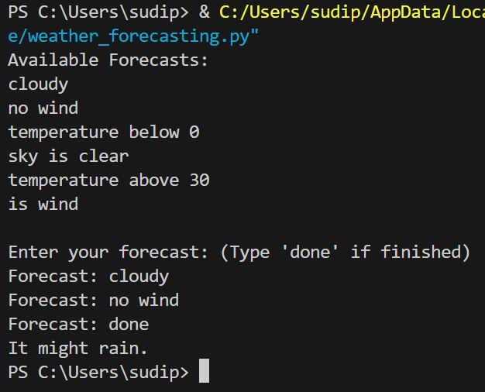

**2. Eligibility for a Loan**

**Rule 1:If applicant's age is between 18 and 65 and they have a stable income, then**

**they are eligible for a loan.**

**Rule 2:If applicant has a credit score above 700, then they are eligible for a loan.**

**Rule 3:If applicant has a criminal record, then they are not eligible for a loan.**

**Rule 4:If applicant has defaulted on a loan before, then they are not eligible for**

**a loan.**

**#Python Code**

#Loan Eligibility

def eligibility(detail,age):

if "Criminal record" in detail:

return "Not eligible for a loan."

if "Loan before" in detail:

return "Not eligible for a loan."

if "Credit Score above 700" in detail:

return "Eligible for Loan"

if age >= 18 and age <= 65 and "Stable income" in detail:

return "Eligible for Loan"

return "Not clear criteria"

def main():

details =[]

age = None

print(" Eligibility for Loan:")

print("Age between 18 & 65")

print("Stable Income")

print("Credit Score above 700")

print("Criminal Record")

print("Loan Before")

print("Enter applicant's details (type 'done' when finished):")

while True:

detail = input("Details: ")

if detail == "done":

break

try:

temp_value = int(detail)

age = temp_value

except ValueError:

details.append(detail)

print(eligibility(details,age))

main()

**Output:**

**3. Simple Decision Making**

**Rule 1: If the time is between 6 AM and 8 AM and it's a weekday, then it's time to go to work.**

**Rule 2: If the time is between 12 PM and 1 PM, then it's time for lunch.**

**Rule 3: If the time is between 9 PM and 10 PM, then it's time to go to bed.**

**Rule 4: If it's the weekend and the weather is sunny, then go for a walk.**

**#Python Code**

from datetime import datetime

def make_decision(time, day_of_week, weather):

    current_time = datetime.strptime(time, "%H:%M").time()

    if current_time >= datetime.strptime("06:00", "%H:%M").time() and current_time <= datetime.strptime("08:00", "%H:%M").time() and day_of_week in ["Monday", "Tuesday", "Wednesday", "Thursday", "Friday"]:

        return "Time to go to work."

    if current_time >= datetime.strptime("12:00", "%H:%M").time() and current_time <= datetime.strptime("13:00", "%H:%M").time():

        return "Time for lunch."

    if current_time >= datetime.strptime("21:00", "%H:%M").time() and current_time <= datetime.strptime("22:00", "%H:%M").time():

        return "Time to go to bed."

    if day_of_week in ["Saturday", "Sunday"] and weather == "sunny":

        return "Go for a walk."

    return "No specific action at this time."

def main():

    time = input("Enter the current time (HH:MM): ")

    day_of_week = input("Enter the day of the week: ").capitalize()

    weather = input("Enter the weather (sunny/cloudy/rainy/etc.): ").lower()

    decision = make_decision(time, day_of_week, weather)

    print(decision)

main()

**Output:**

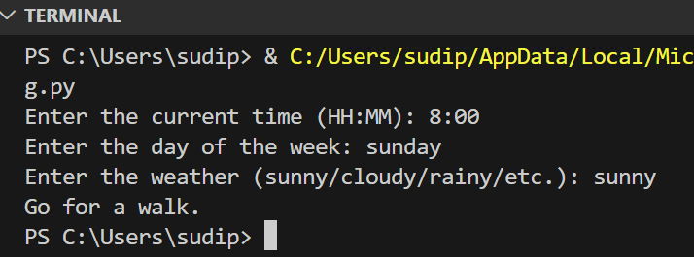

**4. Traffic Light Control**

**Rule 1: If the light is red, then cars must stop.**

**Rule 2: If the light is green, then cars can go.**

**Rule 3: If the light is yellow, then cars must slow down and prepare to stop.**

**Rule 4: If the pedestrian button is pressed, then the light will turn red after a short delay.**

**#Python Code**

#Traffic Light Control

def lightControl(light,pedestrianbutton):

if "red" in light :

return "Cars must stop."

if "green" in light :

return "Cars must go."

if "yellow" in light :

return "Cars must slow down and prepare to stop."

if "Yes" in pedestrianbutton :

return "The light will turn red after a short delay."

return "Not clear criteria"

def main():

print("Traffic Light Control")

print("Enter the color of traffic light and is the pedestrian button pressed? :")

lights = input("Light: ")

button = input("Pedestrain button pressed or not ? (Yes or No:)")

print(lightControl(lights,button))

main()

**Output:**

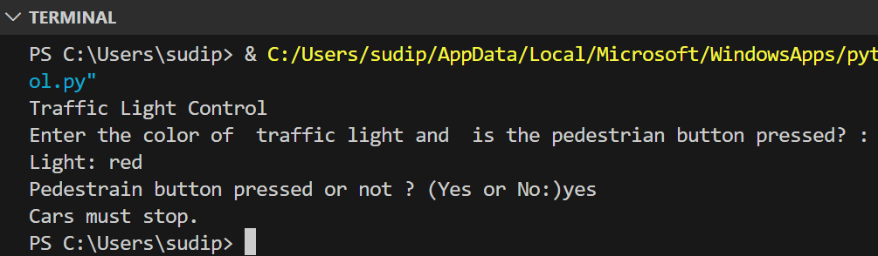

**5. Smart Home Automation**

**Rule 1: If the temperature is below 18°C, then turn on the heater.**

**Rule 2: If the temperature is above 25°C, then turn on the air conditioner.**

**Rule 3: If it is dark outside and someone is at home, then turn on the lights.**

**Rule 4: If the security system is armed and a door is opened, then sound the alarm.**

**#Python Code:**

#Smart Home Automation

def smart(automate,temperature):

        if "Dark Outside" in automate and "Someone is at home" in automate:

            return "Turn on the lights."

        if "Security System is armed" in automate and  "Door Opened" in automate:

            return "Sound the alarm."

        if  temperature is not None and  temperature < 18 :

            return "Turn on the heater."

        if  temperature is not None and  temperature > 25 :

            return "Turn on the air conditioner."

        return "Not clear criteria"

def main():

    automater =[]

    temperature = None

    print("Enter Enviroment details (type 'done' when finished):")

    while True:

        automate = input("Temperature or Environment Details: ")

        if automate == "done":

            break

        try:

            temp_value = int(automate)

            temperature = temp_value

        except ValueError:

            automater.append(automate)

    print(smart(automater,temperature))

main()

**Output:**

**Conclusion:**

In this lab, various rule-based systems were successfully designed and implemented in Python. By applying logical conditions, the systems accurately predicted outcomes and automated decision-making processes for scenarios such as weather forecasting, traffic light control, and time control. This demonstrated the effectiveness of rule-based systems in handling structured decision-making tasks.